XTMP quick start

前提
本地PC正确安装了Xplorer-6.0.1，VS2012，VS2013
在Xplorer-6.0.1下正确导入了MCU的package：viatie(for B0)；以及rfviatieloop16(for C0，暂时不支持)

MixVector

Build MixVector ELF
- 修改config.mk
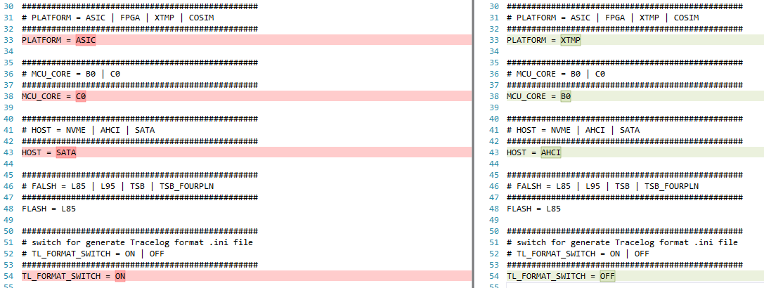
- 创建如下空文件
$(GIT_ROOT)\Bin\bin\AHCI_MCU0_L85_B0_XTMP.elf
- 启动tool/start_xtensa_shell_B0.bat
- xt-make dep
- xt-make mixvector
- 编译出的elf在Bin/bin/ MIXVECTOR_MCU12_L85_B0_XTMP.elf

Build XTMP simulator and run
1. 为Windows系统环境变量PATH，加上：
C:\usr\xtensa\XtDevTools\install\tools\RE-2014.5-win32\XtensaTools\lib\iss-vc110
2. 新建环境变量
XtensaToolsDir = C:\usr\xtensa\XtDevTools\install\tools\RE-2014.5-win32\XtensaTools
3. 运行cmd console，输入 set PATH = C: 然后回车并退出console
4. 用VS2013打开XTMP project，注意确认project setting内configuration properties/general/platform toolset为vs2012
5. 修改model_config.h，#define BL_SUBSYSTEM_PU_NUM 2
6. 修改xtmp_main.c内ELF的路径
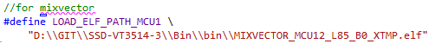
7. 运行256GStorage目录下的10个bat
8. 复制ENV\checklist\normal_pattern\checklist0_file.ini至ENV\checklist\ checklist0_file.ini
9. compile and run XTMP simulator
10. shell界面启动xt-gdb，开始debug elf
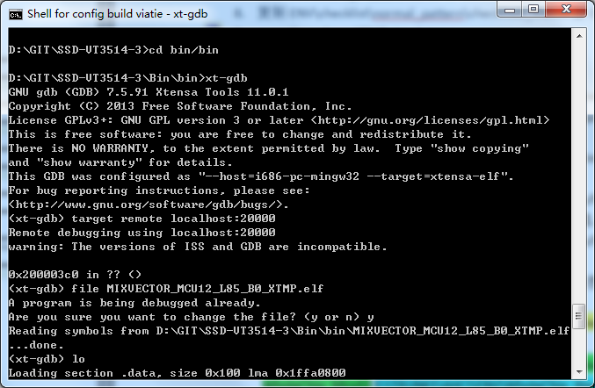

Wholechip(SATA)

Build 3-core ELF
- 修改config.mk
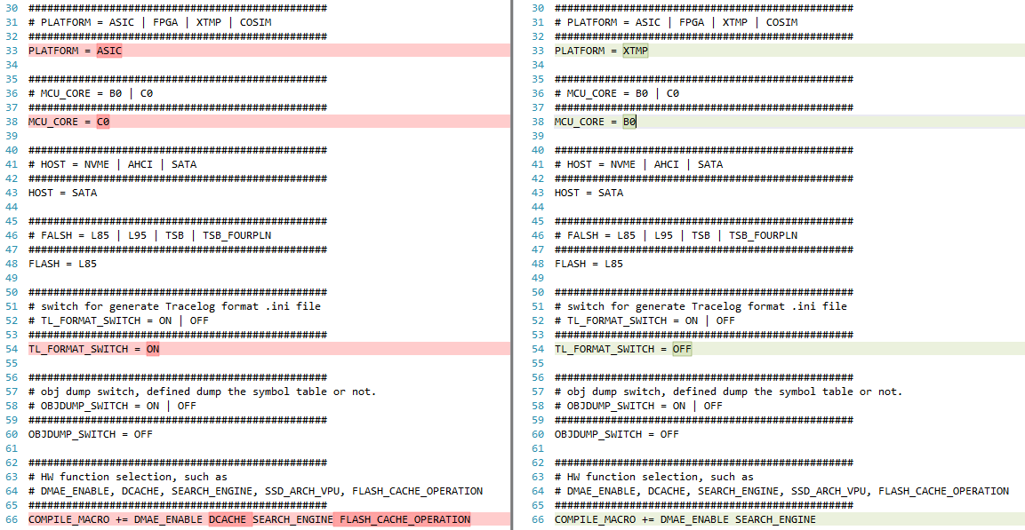
- 启动tool/start_xtensa_shell_B0.bat
- xt-make dep
- xt-make
- 编译出的elf在Bin/bin/…

Build XTMP simulator and run
1. 为Windows系统环境变量PATH，加上：
C:\usr\xtensa\XtDevTools\install\tools\RE-2014.5-win32\XtensaTools\lib\iss-vc110
2. 新建环境变量
XtensaToolsDir = C:\usr\xtensa\XtDevTools\install\tools\RE-2014.5-win32\XtensaTools
3. 运行cmd console，输入 set PATH = C: 然后回车并退出console
4. 用VS2013打开XTMP project，注意确认project setting内configuration properties/general/platform toolset为vs2012；删除Preprocessor Definitions内的MIX_VECTOR项；将Additional Include Directories内的..\..\..\unit_test\MixVector_MainFlow改为..\..\..\firmware/config
5. 修改model_config.h，#define BL_SUBSYSTEM_PU_NUM 1
6. 修改xtmp_main.c内ELF的路径
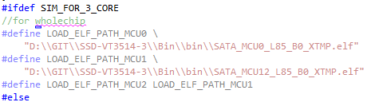
7.运行256GStorage目录下的10个bat
8.复制ENV\checklist\normal_pattern\checklist0_file.ini至ENV\checklist\ checklist0_file.ini
9.compile and run XTMP simulator
10.shell界面启动xt-gdb，开始debug elf，先run MCU0，后run MCU12。注意：由于WholeChip是3-core同时工作，因此需要打开3个xt-gdb分别调试。target remote localhost:后跟的port分别是20000/20001/20002

